UNITED STATES
SECURITIES AND EXCHANGE COMMISSION
Washington, D.C. 20549

FORM 6-K

REPORT OF FOREIGN PRIVATE ISSUER
Pursuant to Rule 13a-16 or 15d-16
under the Securities Exchange Act of 1934

For the Month of August 2026

Commission File Number: 001-37668

FERROGLOBE PLC
(Name of Registrant)
​
13 Chesterfield Street,
London W1J 5JN, United Kingdom
(Address of Principal Executive Office)
​
Indicate by check mark whether the registrant files or will file annual reports under cover of Form 20-F or Form 40-F.

Form 20-F ☒ | Form 40-F ☐

​
​

​
​

​
This Form 6-K consists of the following materials, which appear immediately following this page:
​
 | ● | Press release dated August 4, 2026 announcing results for the quarter ended June 30, 2026
 | ● | Second quarter 2026 earnings call presentation
​
​
This Form 6-K is being furnished for the purpose of incorporating by reference the information in this Form 6-K into (a) Registration Statement No. 333-208911 on Form S-8, and (b) Registration Statement No. 333-258254 on Form F-3 and related prospectuses, as such registration statements and prospectuses may be amended from time to time.
​
​

SIGNATURES
​
Pursuant to the requirements of the Securities Exchange Act of 1934, the registrant has duly caused this report to be signed on its behalf by the undersigned, thereunto duly authorized.

 | Date: August 4, 2026
​ | FERROGLOBE PLC
 | by | /s/ Marco Levi
 |  | Name: Marco Levi
 |  | Title: Chief Executive Officer (Principal Executive Officer)
​
​
​

​
Ferroglobe Reports Second Quarter 2026 Financial Results
​
Second Quarter Highlights
​
 | • | Strong sequential shipment growth, driven by increased silicon metal volumes in EMEA and the U.S.
 | • | Reporting second quarter adjusted EBITDA of $13.1 million
 | • | Ended the quarter with total cash of $93.2 million and net debt of $37.7 million
• Advancing strategic critical materials initiatives, leveraging existing assets to support growing demand for secure Western supply chains
 | • | Paid quarterly dividend of $0.015 per share on June 30; Next dividend of $0.015 payable on September 29
​
​
LONDON, August 4, 2026 (GLOBE NEWSWIRE) – Ferroglobe PLC (NASDAQ: GSM) (“Ferroglobe”, the “Company”, or the “Parent”), a leading global producer of silicon metal, silicon-based and manganese-based specialty alloys, today announced financial results for the second quarter of 2026.
​
Financial Highlights
​ | ​ | ​ | ​ | ​ | ​ | ​ | ​ | ​ | ​ | ​ | ​ | ​ | ​ | ​ | ​ | ​ | ​ | ​ | ​ | ​ | ​ | ​ | ​ | ​
​ | ​ ​ ​ | ​ |  | ​ ​ ​ | ​ |  | ​ | % |  | ​ | ​ |  | ​ | % |  | ​ | ​ | ​ | ​ | ​ | ​ | ​ | %
($ in millions, except EPS) | ​ | Q2 2026 |  | ​ | Q1 2026 |  | ​ | Q/Q |  | ​ | Q2 2025 |  | ​ | Y/Y |  | ​ | YTD 2026 |  | ​ | YTD 2025 |  | ​ | Y/Y
​ | ​ | ​ | ​ | ​ | ​ | ​ | ​ | ​ | ​ | ​ | ​ | ​ | ​ | ​ | ​ | ​ | ​ | ​ | ​ | ​ | ​ | ​ | ​ | ​
Sales | ​ | $ | 378.6 | ​ | $ | 347.7 | ​ | ​ | 8.9% | ​ | $ | 386.9 | ​ | ​ | (2.1)% | ​ | $ | 726.4 | ​ | $ | 694.0 | ​ | ​ | 4.7%
Net profit (loss) attributable to the parent | ​ | $ | 60.4 | ​ | $ | (7.1) | ​ | ​ | 956.0% | ​ | $ | (10.5) | ​ | ​ | 677.7% | ​ | $ | 53.3 | ​ | $ | (76.9) | ​ | ​ | 169.3%
Adj. EBITDA | ​ | $ | 13.1 | ​ | $ | 3.3 | ​ | ​ | 291.2% | ​ | $ | 21.6 | ​ | ​ | (39.3)% | ​ | $ | 16.4 | ​ | $ | (5.2) | ​ | ​ | 416.2%
Adjusted diluted EPS | ​ | $ | 0.00 | ​ | $ | (0.07) | ​ | ​ | 106.2% | ​ | $ | (0.08) | ​ | ​ | 105.4% | ​ | $ | (0.07) | ​ | $ | (0.28) | ​ | ​ | 73.9%
Operating cash flow | ​ | $ | 37.0 | ​ | $ | (5.6) | ​ | ​ | 764.0% | ​ | $ | 15.6 | ​ | ​ | 136.7% | ​ | $ | 31.4 | ​ | $ | 35.0 | ​ | ​ | (10.3)%
Capital expenditures1 | ​ | $ | 16.6 | ​ | $ | 10.9 | ​ | ​ | 52.7% | ​ | $ | 15.6 | ​ | ​ | 6.3% | ​ | $ | 27.4 | ​ | $ | 29.9 | ​ | ​ | (8.2)%
Free cash flow2 | ​ | $ | 20.4 | ​ | $ | (16.4) | ​ | ​ | 224.1% | ​ | $ | 0.0 | ​ | ​ | n.m | ​ | $ | 4.0 | ​ | $ | 5.1 | ​ | ​ | (22.5)%
 | (1) | Cash outflows for capital expenditures
 | (2) | Free cash flow is calculated as operating cash flow less capital expenditures
​
​
Dr. Marco Levi, Ferroglobe’s Chief Executive Officer, commented, “Our second quarter results reflect solid execution of our strategy despite a challenging pricing environment. Strong volume growth, positive free cash flow generation, and further debt reduction reinforce the resilience of our operating platform and our disciplined approach to capital allocation.
​
“At the same time, we continue to advance the development of our critical materials strategy by leveraging our existing industrial footprint, metallurgical expertise, and established customer relationships to create new avenues for growth. Combined with increasing support for Western supply chains and domestic production, we believe Ferroglobe is uniquely positioned to benefit from the growing focus on critical materials, industrial security, and onshoring initiatives across the U.S. and Europe,” concluded Dr. Levi.
​
Consolidated Sales
​
In the second quarter of 2026, Ferroglobe reported sales of $378.6 million, an 8.9% increase from the prior quarter and a 2.1% decrease from the comparable prior-year period. The sequential improvement was mainly driven by higher sales volumes of silicon metal and silicon-based alloys, as well as higher average selling prices for manganese-based alloys, partially offset by lower sales volumes for manganese-based alloys and lower average selling prices for silicon metal and silicon-based alloys. Sales of silicon metal increased by $21.7 million, silicon-based alloys increased by $2.6 million, and manganese-based alloys increased by $0.5 million compared with the prior quarter.
​
​

​
​
Product Category Highlights
​
Silicon Metal
​
​ | ​ | ​ | ​ | ​ | ​ | ​ | ​ | ​ | ​ | ​ | ​ | ​ | ​ | ​ | ​ | ​ | ​ | ​ | ​ | ​ | ​
​ | ​ ​ ​ | ​ |  | ​ | ​ |  | ​ | ​ | ​ | ​ |  | ​ | ​ | ​ | ​ |  | ​ | ​ |  | ​
($,000) | ​ | Q2 2026 |  | ​ | Q1 2026 |  | ​ | % Q/Q | ​ | Q2 2025 |  | ​ | % Y/Y | ​ | YTD 2026 |  | ​ | YTD 2025 |  | ​ | % Y/Y
Shipments in metric tons: | ​ | ​ | 40,818 | ​ | ​ | 30,533 | ​ | 33.7% | ​ | ​ | 44,610 | ​ | (8.5)% | ​ | ​ | 71,351 | ​ | ​ | 80,918 | ​ | (11.8)%
Average selling price ($/MT): | ​ | ​ | 2,592 | ​ | ​ | 2,754 | ​ | (5.9)% | ​ | ​ | 2,916 | ​ | (11.1)% | ​ | ​ | 2,661 | ​ | ​ | 2,900 | ​ | (8.2)%
​ | ​ | ​ | ​ | ​ | ​ | ​ | ​ | ​ | ​ | ​ | ​ | ​ | ​ | ​ | ​ | ​ | ​ | ​ | ​ | ​ | ​
Silicon Metal Revenue | ​ | ​ | 105,800 | ​ | ​ | 84,088 | ​ | 25.8% | ​ | ​ | 130,083 | ​ | (18.7)% | ​ | ​ | 189,865 | ​ | ​ | 234,662 | ​ | (19.1)%
Silicon Metal Adj.EBITDA | ​ | ​ | (2,658) | ​ | ​ | (2,275) | ​ | 16.8% | ​ | ​ | 6,521 | ​ | (140.8)% | ​ | ​ | (4,933) | ​ | ​ | (8,926) | ​ | (44.7)%
Silicon Metal Adj.EBITDA Margin | ​ | ​ | (2.5)% | ​ | ​ | (2.7)% | ​ | ​ | ​ | ​ | 5.0% | ​ | ​ | ​ | ​ | (2.6)% | ​ | ​ | (3.8)% | ​ | ​
​
Silicon metal revenue in the second quarter was $105.8 million, an increase of 25.8% from the prior quarter. The average selling price decreased by 5.9%, driven by lower pricing across the U.S. and EMEA, as elevated market availability and cautious customer purchasing continued to weigh on realized prices, particularly in Europe. Shipments increased 33.7%, reflecting higher volumes in both EMEA and the U.S. Adjusted EBITDA decreased to $(2.7) million in the second quarter, as compared with $(2.3) million in the prior quarter, primarily due to lower realized pricing. Adjusted EBITDA margin improved to (2.5%) in the second quarter from (2.7%) in the prior quarter.
​
Silicon-Based Alloys
​
​ | ​ | ​ | ​ | ​ | ​ | ​ | ​ | ​ | ​ | ​ | ​ | ​ | ​ | ​ | ​ | ​ | ​ | ​ | ​ | ​ | ​
($,000) | ​ | Q2 2026 |  | ​ | Q1 2026 |  | ​ | % Q/Q | ​ | Q2 2025 |  | ​ | % Y/Y | ​ | YTD 2026 |  | ​ | YTD 2025 |  | ​ | % Y/Y
Shipments in metric tons: | ​ | ​ | 62,915 | ​ | ​ | 60,674 | ​ | 3.7% | ​ | ​ | 53,048 | ​ | 18.6% | ​ | ​ | 123,589 | ​ | ​ | 95,913 | ​ | 28.9%
Average selling price ($/MT): | ​ | ​ | 1,986 | ​ | ​ | 2,016 | ​ | (1.5)% | ​ | ​ | 2,105 | ​ | (5.7)% | ​ | ​ | 2,001 | ​ | ​ | 2,112 | ​ | (5.3)%
​ | ​ | ​ | ​ | ​ | ​ | ​ | ​ | ​ | ​ | ​ | ​ | ​ | ​ | ​ | ​ | ​ | ​ | ​ | ​ | ​ | ​
Silicon-based Alloys Revenue | ​ | ​ | 124,949 | ​ | ​ | 122,319 | ​ | 2.2% | ​ | ​ | 111,666 | ​ | 11.9% | ​ | ​ | 247,302 | ​ | ​ | 202,568 | ​ | 22.1%
Silicon-based Alloys Adj.EBITDA | ​ | ​ | 14,516 | ​ | ​ | 6,850 | ​ | 111.9% | ​ | ​ | 7,158 | ​ | 102.8% | ​ | ​ | 21,366 | ​ | ​ | 9,572 | ​ | 123.2%
Silicon-based Alloys Adj.EBITDA Margin | ​ | ​ | 11.6% | ​ | ​ | 5.6% | ​ | ​ | ​ | ​ | 6.4% | ​ | ​ | ​ | ​ | 8.6% | ​ | ​ | 4.7% | ​ | ​
​
Silicon-based alloy revenue in the second quarter was $124.9 million, an increase of 2.2% from the prior quarter. The average selling price decreased by 1.5%, as higher realized prices in South Africa were more than offset by softer pricing in Europe and the U.S. amid subdued steel demand and ample market availability. Shipments increased 3.7%, primarily reflecting stronger volumes in Europe, partially offset by lower volumes in South Africa and the U.S. Adjusted EBITDA increased to $14.5 million in the second quarter of 2026, compared with $6.8 million in the prior quarter, primarily driven by improved operating costs and higher shipments, partially offset by lower realized pricing. Adjusted EBITDA margin increased to 11.6% in the second quarter, compared with 5.6% in the prior quarter.
​
Manganese-Based Alloys
​
​ | ​ | ​ | ​ | ​ | ​ | ​ | ​ | ​ | ​ | ​ | ​ | ​ | ​ | ​ | ​ | ​ | ​ | ​ | ​ | ​ | ​
​ | ​ ​ ​ | ​ |  | ​ ​ ​ | ​ |  | ​ | ​ | ​ ​ ​ | ​ |  | ​ | ​ | ​ | ​ |  | ​ | ​ |  | ​
($,000) | ​ | Q2 2026 |  | ​ | Q1 2026 |  | ​ | % Q/Q | ​ | Q2 2025 |  | ​ | % Y/Y | ​ | YTD 2026 |  | ​ | YTD 2025 |  | ​ | % Y/Y
Shipments in metric tons: | ​ | ​ | 84,752 | ​ | ​ | 85,743 | ​ | (1.2)% | ​ | ​ | 88,188 | ​ | (3.9)% | ​ | ​ | 170,495 | ​ | ​ | 155,417 | ​ | 9.7%
Average selling price ($/MT): | ​ | ​ | 1,270 | ​ | ​ | 1,250 | ​ | 1.6% | ​ | ​ | 1,204 | ​ | 5.5% | ​ | ​ | 1,260 | ​ | ​ | 1,162 | ​ | 8.4%
​ | ​ | ​ | ​ | ​ | ​ | ​ | ​ | ​ | ​ | ​ | ​ | ​ | ​ | ​ | ​ | ​ | ​ | ​ | ​ | ​ | ​
Manganese-based Alloys Revenue | ​ | ​ | 107,635 | ​ | ​ | 107,179 | ​ | 0.4% | ​ | ​ | 106,178 | ​ | 1.4% | ​ | ​ | 214,824 | ​ | ​ | 180,595 | ​ | 19.0%
Manganese-based Alloys Adj.EBITDA | ​ | ​ | 13,014 | ​ | ​ | 10,014 | ​ | 30.0% | ​ | ​ | 16,794 | ​ | (22.5)% | ​ | ​ | 23,028 | ​ | ​ | 11,220 | ​ | 105.2%
Manganese-based Alloys Adj.EBITDA Margin | ​ | ​ | 12.1% | ​ | ​ | 9.3% | ​ | ​ | ​ | ​ | 15.8% | ​ | ​ | ​ | ​ | 10.7% | ​ | ​ | 6.2% | ​ | ​
​
Manganese-based alloy revenue in the second quarter was $107.6 million, an increase of 0.4% from the prior quarter. The average selling price increased by 1.6%, reflecting higher pricing in both Europe and the U.S. In Europe, pricing was
​

supported by the impact of EU safeguard measures and additional duties on certain imports, despite continued weakness in underlying demand. Shipments decreased 1.2%, primarily reflecting lower volumes in Europe, partially offset by a modest increase in the U.S. Adjusted EBITDA increased to $13.0 million in the second quarter, compared with $10.0 million in the prior quarter, primarily reflecting higher realized pricing, improved operating performance, and a more favorable sales mix, partially offset by higher manganese ore, energy, and transportation costs. Adjusted EBITDA margin increased to 12.1% in the second quarter, compared with 9.3% in the prior quarter.
​
Raw materials and energy consumption for production
​
Raw materials and energy consumption for production decreased to 51.5% of sales in the second quarter of 2026, compared with 64.3% in the prior quarter. This improvement was primarily driven by the recognition of a $59.9 million positive fair value adjustment related to long-term energy contracts, compared with a $5.5 million gain recognized in the first quarter of 2026. Excluding the impact of power purchase agreements, raw materials and energy consumption represented 67.3% of sales in the second quarter of 2026, compared with 65.9% in the prior quarter, primarily reflecting pressure on realized selling prices across most product categories and changes in the sales mix, while raw material and energy costs did not decline at the same pace, resulting in a narrowing of the price-cost spread.
​
Net Profit (Loss) Attributable to the Parent
​
In the second quarter of 2026, net profit attributable to the parent was $60.4 million, or $0.32 per diluted share, compared to a net loss attributable to the parent of $7.1 million, or $(0.04) per diluted share, in the prior quarter. The return to profitability primarily reflected a $59.9 million positive fair value adjustment related to long-term energy contracts, as well as improved operating performance, partially offset by higher selling expenses associated with increased sales volumes. The Company reported breakeven adjusted diluted earnings per share for the second quarter of 2026, compared with an adjusted diluted loss per share of $(0.07) in the prior quarter.
​
Adjusted EBITDA
​
Adjusted EBITDA increased to $13.1 million in the second quarter of 2026, compared with $3.3 million in the prior quarter. The sequential improvement reflected stronger shipment volumes and improved operating performance across the portfolio, supported by continued cost efficiency initiatives. These benefits were partially offset by higher selling and distribution costs.
​
Total Cash, Adjusted Gross Debt and Working Capital
​
​ | ​ | ​ | ​ | ​ | ​ | ​ | ​ | ​ | ​ | ​ | ​ | ​ | ​ | ​ | ​ | ​ | ​ | ​ | ​ | ​
​ | ​ ​ ​ | ​ |  | ​ ​ ​ | ​ |  | ​ | ​ |  | ​ | ​ |  | ​ | ​ |  | ​ | ​ | ​ | %
($ in millions) | ​ | Q2 2026 |  | ​ | Q1 2026 |  | ​ | $ |  | ​ | % |  | ​ | Q2 2025 |  | ​ | $ |  | Y/Y
​ | ​ | ​ | ​ | ​ | ​ | ​ | ​ | ​ | ​ | ​ | ​ | ​ | ​ | ​ | ​ | ​ | ​ | ​ | ​ | ​
Total Cash1 | ​ | $ | 93.2 | ​ | $ | 96.4 | ​ | ​ | (3.2) | ​ | ​ | (3.3)% | ​ | $ | 135.5 | ​ | ​ | (42.3) | ​ | (31.2)%
Adjusted Gross Debt2 | ​ | $ | 130.9 | ​ | $ | 151.0 | ​ | ​ | (20.1) | ​ | ​ | (13.3)% | ​ | $ | 125.2 | ​ | ​ | 5.7 | ​ | 4.6%
Net (Debt) Cash | ​ | $ | (37.7) | ​ | $ | (54.6) | ​ | ​ | 16.9 | ​ | ​ | 31.0% | ​ | $ | 10.3 | ​ | ​ | (48.0) | ​ | (465.8)%
Total Working Capital3 | ​ | $ | 398.4 | ​ | $ | 431.2 | ​ | ​ | (32.8) | ​ | ​ | (7.6)% | ​ | $ | 440.8 | ​ | ​ | (42.4) | ​ | (9.6)%
 | (1) | Total cash is comprised of restricted cash and cash and cash equivalents
(2) Adjusted gross debt excludes bank borrowings on our factoring program and the impact of leasing standard IFRS16
(3) Total working capital is comprised of inventories, trade receivables and other receivables minus trade and other payables
​
​
Total cash was $93.2 million as of June 30, 2026, a decrease of $3.2 million from $96.4 million as of March 31, 2026. Adjusted gross debt decreased by $20.1 million to $130.9 million, resulting in net debt of $37.7 million as of June 30, 2026, representing a decrease of $16.9 million from the prior quarter.
​
During the second quarter, cash flows provided by operating activities were $37.0 million, and net cash used in investing activities was $13.6 million. Cash used in financing activities was $25.9 million as a result of lease payments of $3.9 million, dividend payments of $2.8 million, interest payments of $3.7 million, the principal repayments of other financing liabilities of $4.6 million, and financing facilities payments in South Africa, France and Spain totaling $11.4 million, partially offset by net cash proceeds from the sale of short-term commercial paper totaling $0.5 million.
​
Total working capital was $398.4 million as of June 30, 2026, a decrease of $32.8 million from $431.2 million at the end of the prior quarter. The decrease in our working capital balance during the quarter was primarily driven by a decrease of $12.8
​

million in inventories, $7.8 million in other receivables and an increase of $20.7 million in trade and other payables, partially offset by an $8.6 million increase in trade receivables.
​
Beatriz García-Cos, Ferroglobe’s Chief Financial Officer, commented, “The second quarter reflected a meaningful improvement in operating performance, with adjusted EBITDA increasing to $13.1 million, from $3.3 million in the first quarter, free cash flow of $20.4 million, and net debt declining to $37.7 million. Higher shipment volumes, disciplined working capital management, and continued cost control drove solid cash generation and further strengthened our balance sheet. With ample liquidity, reduced leverage, and a consistent dividend, we remain focused on maintaining financial flexibility while supporting the growth opportunities emerging from our core business and strategic critical materials initiatives.”
​
Capital Returns
​
During the second quarter, Ferroglobe did not repurchase shares and paid a quarterly cash dividend of $ 0.015 per share on June 30, 2026. Our next cash dividend of $0.015 per share will be paid on September 29, 2026, to shareholders of record as of September 22, 2026.
​
Conference Call
​
Ferroglobe invites all interested persons to participate in our conference call at 8:30 AM, Eastern Time on August 5, 2026. The call may also be accessed via an audio webcast.
​
To join via phone:
Conference call participants should pre-register using this link:
https://register-conf.media-server.com/register/BI66a0208bb9f34859af10be34832acc52
​
Once registered, you will receive the dial-in numbers and a personal PIN, which are required to access the conference call.
​
To join via webcast:
​
A simultaneous audio webcast and replay will be accessible here:
https://edge.media-server.com/mmc/p/ekm3qzst
​
About Ferroglobe
​
Ferroglobe PLC is a leading global producer of silicon metal, silicon- and manganese- based specialty alloys and ferroalloys, serving a customer base across the globe in dynamic and fast-growing end markets, such as solar, electronics, automotive, consumer products, construction, and energy. The Company is based in London. For more information, visit http://investor.ferroglobe.com.
​
Forward-Looking Statements
​
This release contains “forward-looking statements” within the meaning of U.S. securities laws. Forward-looking statements are not historical facts but are based on certain assumptions of management and describe the Company’s future plans, strategies and expectations. Forward-looking statements often use forward-looking terminology, including words such as “anticipate”, “believe”, “could”, “estimate”, “expect”, “should”,“forecast”, “guidance”, “intends”, “likely”, “may”, “plan”, “potential”, “predicts”, “seek”, “target”, “will” and words of similar meaning or the negative thereof.
​
Forward-looking statements contained in this press release are based on information currently available to the Company and assumptions that management believe to be reasonable, but are inherently uncertain. As a result, Ferroglobe’s actual results, performance or achievements may differ materially from those expressed or implied by these forward-looking statements, which are not guarantees of future performance and involve known and unknown risks, uncertainties and other factors that are, in some cases, beyond the Company’s control.
​
Forward-looking financial information and other metrics presented herein represent the Company’s goals and are not intended as guidance or projections for the periods referenced herein or any future periods.
​

​
All information in this press release is as of the date of its release. Ferroglobe does not undertake any obligation to update publicly any of the forward-looking statements contained herein to reflect new information, events or circumstances arising after the date of this press release. You should not place undue reliance on any forward-looking statements, which are made only as of the date of this press release.
​
​
​
Non-IFRS Measures
​
This document may contain summarized, non-audited or non-IFRS financial information. The information contained herein should therefore be considered as a whole and in conjunction with all the public information regarding the Company available, including any other documents released by the Company that may contain more detailed information. Adjusted EBITDA, adjusted EBITDA as a percentage of sales, working capital as a percentage of sales, adjusted EBITDA margin, working capital, adjusted net profit, adjusted diluted EPS, adjusted gross debt and net cash/(debt), are non-IFRS financial metrics that management uses in its decision making. Ferroglobe has included these financial metrics to provide supplemental measures of its performance. The Company believes these metrics are important and useful to investors because they eliminate items that have less bearing on the Company’s current and future operating performance and highlight trends in its core business that may not otherwise be apparent when relying solely on IFRS financial measures.
​

​
​
​
INVESTOR CONTACT:
​
Alex Rotonen, CFA
Vice President, Investor Relations
Email: investor.relations@ferroglobe.com
​
MEDIA CONTACT:
​
Cristina Feliu Roig
Vice President, Communications & Public Affairs
Email: corporate.comms@ferroglobe.com
​
​
​

Ferroglobe PLC and Subsidiaries
Unaudited Condensed Consolidated Income Statement
(in thousands of U.S. dollars, except per share amounts)
​
​
​ | ​ | ​ | ​ | ​ | ​ | ​ | ​ | ​ | ​ | ​ | ​ | ​ | ​ | ​ | ​ | ​
​ | ​ | ​ | For the Three Months Ended | ​ | ​ | For the Three Months Ended | ​ | ​ | For the Three Months Ended | ​ | ​ | For the Six Months Ended | ​ | ​ | For the Six Months Ended | ​
​ | ​ ​ ​ | June 30, 2026 |  | ​ ​ ​ | March 31, 2026 |  | ​ | ​ | June 30, 2025 |  | ​ | June 30, 2026 |  | ​ | June 30, 2025
Sales | ​ | $ | 378,620 | ​ | $ | 347,745 | ​ | $ | 386,862 | ​ | $ | 726,365 | ​ | $ | 694,041 | ​
Raw materials and energy consumption for production | ​ | ​ | (195,066) | ​ | ​ | (223,488) | ​ | ​ | (253,212) | ​ | ​ | (418,554) | ​ | ​ | (491,553) | ​
Other operating income | ​ | ​ | 33,606 | ​ | ​ | 20,492 | ​ | ​ | 26,893 | ​ | ​ | 54,098 | ​ | ​ | 35,965 | ​
Staff costs | ​ | ​ | (68,063) | ​ | ​ | (64,140) | ​ | ​ | (68,797) | ​ | ​ | (132,203) | ​ | ​ | (139,247) | ​
Other operating expense | ​ | ​ | (76,409) | ​ | ​ | (71,765) | ​ | ​ | (64,535) | ​ | ​ | (148,174) | ​ | ​ | (111,825) | ​
Depreciation and amortization | ​ | ​ | (15,541) | ​ | ​ | (16,601) | ​ | ​ | (18,301) | ​ | ​ | (32,142) | ​ | ​ | (35,821) | ​
Impairment gain | ​ | ​ | — | ​ | ​ | — | ​ | ​ | — | ​ | ​ | — | ​ | ​ | 268 | ​
Other (loss) gain | ​ | ​ | (192) | ​ | ​ | 42 | ​ | ​ | (172) | ​ | ​ | (150) | ​ | ​ | 1,233 | ​
Operating profit (loss) | ​ | ​ | 56,955 | ​ | ​ | (7,715) | ​ | ​ | 8,738 | ​ | ​ | 49,240 | ​ | ​ | (46,939) | ​
Finance income | ​ | ​ | 1,907 | ​ | ​ | 708 | ​ | ​ | 970 | ​ | ​ | 2,615 | ​ | ​ | 1,843 | ​
Finance costs | ​ | ​ | (3,482) | ​ | ​ | (5,922) | ​ | ​ | (4,770) | ​ | ​ | (9,402) | ​ | ​ | (9,325) | ​
Exchange differences | ​ | ​ | 5,138 | ​ | ​ | 1,783 | ​ | ​ | (19,659) | ​ | ​ | 6,921 | ​ | ​ | (26,573) | ​
Profit (loss) before tax | ​ | ​ | 60,518 | ​ | ​ | (11,146) | ​ | ​ | (14,721) | ​ | ​ | 49,374 | ​ | ​ | (80,994) | ​
Income tax (expense) / benefit | ​ | ​ | 48 | ​ | ​ | 4,010 | ​ | ​ | 3,787 | ​ | ​ | 4,057 | ​ | ​ | 3,162 | ​
Total profit (loss) for the period | ​ | ​ | 60,566 | ​ | ​ | (7,136) | ​ | ​ | (10,934) | ​ | ​ | 53,431 | ​ | ​ | (77,832) | ​
​ | ​ | ​ | ​ | ​ | ​ | ​ | ​ | ​ | ​ | ​ | ​ | ​ | ​ | ​ | ​ | ​
Profit (loss) attributable to the parent | ​ | $ | 60,374 | ​ | $ | (7,053) | ​ | $ | (10,451) | ​ | $ | 53,322 | ​ | $ | (76,933) | ​
Profit (loss) attributable to non-controlling interest | ​ | ​ | 192 | ​ | ​ | (83) | ​ | ​ | (483) | ​ | ​ | 109 | ​ | ​ | (899) | ​
​ | ​ | ​ | ​ | ​ | ​ | ​ | ​ | ​ | ​ | ​ | ​ | ​ | ​ | ​ | ​ | ​
EBITDA | ​ | $ | 77,634 | ​ | $ | 10,669 | ​ | $ | 7,380 | ​ | $ | 88,303 | ​ | $ | (37,691) | ​
Adjusted EBITDA | ​ | $ | 13,093 | ​ | $ | 3,347 | ​ | $ | 21,562 | ​ | $ | 16,440 | ​ | $ | (5,241) | ​
​ | ​ | ​ | ​ | ​ | ​ | ​ | ​ | ​ | ​ | ​ | ​ | ​ | ​ | ​ | ​ | ​
​ | ​ | ​ | ​ | ​ | ​ | ​ | ​ | ​ | ​ | ​ | ​ | ​ | ​ | ​ | ​ | ​
Weighted average number of shares outstanding | ​ | ​ | ​ | ​ | ​ | ​ | ​ | ​ | ​ | ​ | ​ | ​ | ​ | ​ | ​ | ​
Basic | ​ | ​ | 188,281 | ​ | ​ | 188,286 | ​ | ​ | 188,142 | ​ | ​ | 188,284 | ​ | ​ | 188,583 | ​
Diluted | ​ | ​ | 188,668 | ​ | ​ | 188,286 | ​ | ​ | 188,142 | ​ | ​ | 189,036 | ​ | ​ | 188,583 | ​
​ | ​ | ​ | ​ | ​ | ​ | ​ | ​ | ​ | ​ | ​ | ​ | ​ | ​ | ​ | ​ | ​
Profit (loss) per ordinary share | ​ | ​ | ​ | ​ | ​ | ​ | ​ | ​ | ​ | ​ | ​ | ​ | ​ | ​ | ​ | ​
Basic | ​ | $ | 0.32 | ​ | $ | (0.04) | ​ | $ | (0.06) | ​ | $ | 0.28 | ​ | $ | (0.41) | $
Diluted | ​ | $ | 0.32 | ​ | $ | (0.04) | ​ | $ | (0.06) | ​ | $ | 0.28 | ​ | $ | (0.41) | $
​
​
​

Ferroglobe PLC and Subsidiaries
Unaudited Condensed Consolidated Statement of Financial Position
(in thousands of U.S. dollars)
​
​ | ​ | ​ | ​ | ​ | ​ | ​ | ​ | ​ | ​ | ​
​ | ​ | As of June 30, |  |  | ​ | As of March 31, |  | ​ | As of December 31,
​ | ​ ​ ​ | 2026 |  |  | ​ ​ ​ | 2026 |  | ​ ​ ​ | 2025
ASSETS
Non-current assets | ​ | ​ | ​ | ​ | ​ | ​ | ​ | ​ | ​ | ​
Goodwill | ​ | $ | ​ | 12,472 | ​ | $ | 12,472 | ​ | $ | 12,472
Intangible assets | ​ | ​ | ​ | 203,823 | ​ | ​ | 198,323 | ​ | ​ | 132,682
Property, plant and equipment | ​ | ​ | ​ | 487,026 | ​ | ​ | 480,827 | ​ | ​ | 486,678
Other financial assets | ​ | ​ | ​ | 71,718 | ​ | ​ | 46,054 | ​ | ​ | 26,717
Deferred tax assets | ​ | ​ | ​ | — | ​ | ​ | — | ​ | ​ | —
Receivables from related parties | ​ | ​ | ​ | 1,709 | ​ | ​ | 1,725 | ​ | ​ | 1,763
Other non-current assets | ​ | ​ | ​ | 21,550 | ​ | ​ | 21,516 | ​ | ​ | 21,436
Total non-current assets | ​ | ​ | ​ | 798,298 | ​ | ​ | 760,917 | ​ | ​ | 681,748
Current assets | ​ | ​ | ​ | ​ | ​ | ​ | ​ | ​ | ​ | ​
Inventories | ​ | ​ | ​ | 321,435 | ​ | ​ | 334,265 | ​ | ​ | 306,160
Trade receivables | ​ | ​ | ​ | 220,987 | ​ | ​ | 212,387 | ​ | ​ | 191,536
Other receivables | ​ | ​ | ​ | 83,664 | ​ | ​ | 91,534 | ​ | ​ | 74,665
Current income tax assets | ​ | ​ | ​ | 3,330 | ​ | ​ | 4,922 | ​ | ​ | 5,564
Other financial assets | ​ | ​ | ​ | 6 | ​ | ​ | 4 | ​ | ​ | 11,104
Other current assets | ​ | ​ | ​ | 28,547 | ​ | ​ | 20,671 | ​ | ​ | 21,716
Restricted cash and cash equivalents | ​ | ​ | ​ | 153 | ​ | ​ | 164 | ​ | ​ | 175
Cash and cash equivalents | ​ | ​ | ​ | 93,079 | ​ | ​ | 96,228 | ​ | ​ | 122,812
Total current assets | ​ | ​ | ​ | 751,201 | ​ | ​ | 760,175 | ​ | ​ | 733,732
Total assets | ​ | $ | ​ | 1,549,499 | ​ | $ | 1,521,092 | ​ | $ | 1,415,480
​ | ​ | ​ | ​ | ​ | ​ | ​ | ​ | ​ | ​ | ​
EQUITY AND LIABILITIES
Equity | ​ | $ | ​ | 717,895 | ​ | $ | 670,460 | ​ | $ | 692,257
Non-current liabilities | ​ | ​ | ​ | ​ | ​ | ​ | ​ | ​ | ​ | ​
Deferred income | ​ | ​ | ​ | 61,003 | ​ | ​ | 75,478 | ​ | ​ | 26,394
Provisions | ​ | ​ | ​ | 35,443 | ​ | ​ | 32,081 | ​ | ​ | 30,487
Provision for pensions | ​ | ​ | ​ | 28,496 | ​ | ​ | 28,752 | ​ | ​ | 28,903
Bank borrowings | ​ | ​ | ​ | 39,835 | ​ | ​ | 59,327 | ​ | ​ | 60,136
Lease liabilities | ​ | ​ | ​ | 53,113 | ​ | ​ | 55,523 | ​ | ​ | 57,429
Other financial liabilities | ​ | ​ | ​ | 20,170 | ​ | ​ | 21,022 | ​ | ​ | 22,035
Derivative financial liabilities | ​ | ​ | ​ | 4,012 | ​ | ​ | 37,917 | ​ | ​ | 45,198
Other non-current liabilities | ​ | ​ | ​ | 264 | ​ | ​ | 297 | ​ | ​ | 345
Deferred tax liabilities | ​ | ​ | ​ | 5,876 | ​ | ​ | 8,202 | ​ | ​ | 11,005
Total non-current liabilities | ​ | ​ | ​ | 248,212 | ​ | ​ | 318,599 | ​ | ​ | 281,932
Current liabilities | ​ | ​ | ​ | ​ | ​ | ​ | ​ | ​ | ​ | ​
Provisions | ​ | ​ | ​ | 128,191 | ​ | ​ | 107,200 | ​ | ​ | 87,308
Provision for pensions | ​ | ​ | ​ | 179 | ​ | ​ | 183 | ​ | ​ | 186
Bank borrowings | ​ | ​ | ​ | 89,825 | ​ | ​ | 83,230 | ​ | ​ | 79,876
Lease liabilities | ​ | ​ | ​ | 12,311 | ​ | ​ | 12,482 | ​ | ​ | 12,254
Debt instruments | ​ | ​ | ​ | 28,731 | ​ | ​ | 29,430 | ​ | ​ | 26,014
Other financial liabilities | ​ | ​ | ​ | 6,839 | ​ | ​ | 11,358 | ​ | ​ | 11,408
Derivative financial liabilities | ​ | ​ | ​ | — | ​ | ​ | — | ​ | ​ | —
Payables to related parties | ​ | ​ | ​ | 1,875 | ​ | ​ | 2,726 | ​ | ​ | 2,577
Trade and other payables | ​ | ​ | ​ | 227,678 | ​ | ​ | 206,997 | ​ | ​ | 144,853
Current income tax liabilities | ​ | ​ | ​ | 4,048 | ​ | ​ | 889 | ​ | ​ | 970
Other current liabilities | ​ | ​ | ​ | 83,715 | ​ | ​ | 77,538 | ​ | ​ | 75,845
Total current liabilities | ​ | ​ | ​ | 583,392 | ​ | ​ | 532,033 | ​ | ​ | 441,291
Total equity and liabilities | ​ | $ | ​ | 1,549,499 | ​ | $ | 1,521,092 | ​ | $ | 1,415,480
​
​

Ferroglobe PLC and Subsidiaries
Unaudited Condensed Consolidated Statement of Cash Flows
(in thousands of U.S. dollars)
​
​ | ​ | ​ | ​ | ​ | ​ | ​ | ​ | ​ | ​ | ​ | ​ | ​ | ​ | ​ | ​
​ | ​ | For the Three Months Ended |  | ​ | For the Three Months Ended |  | ​ | For the Three Months Ended |  | ​ | For the Six Months Ended |  | ​ | For the Six Months Ended
​ | ​ ​ ​ | June 30, 2026 |  | ​ | March 31, 2026 |  | ​ | June 30, 2025 |  | ​ | June 30, 2026 |  | ​ | June 30, 2025
Cash flows from operating activities: | ​ | ​ | ​ | ​ | ​ | ​ | ​ | ​ | ​ | ​ | ​ | ​ | ​ | ​ | ​
Profit (loss) for the period | ​ | $ | 60,566 | ​ | $ | (7,136) | ​ | $ | (10,934) | ​ | $ | 53,431 | ​ | $ | (77,832)
Adjustments to reconcile net profit (loss) to net cash (used) provided by operating activities: | ​ | ​ | ​ | ​ | ​ | ​ | ​ | ​ | ​ | ​ | ​ | ​ | ​ | ​ | ​
Income tax (benefit)/expense | ​ | ​ | (48) | ​ | ​ | (4,010) | ​ | ​ | (3,787) | ​ | ​ | (4,057) | ​ | ​ | (3,162)
Depreciation and amortization | ​ | ​ | 15,541 | ​ | ​ | 16,601 | ​ | ​ | 18,301 | ​ | ​ | 32,142 | ​ | ​ | 35,821
Finance income | ​ | ​ | (1,907) | ​ | ​ | (708) | ​ | ​ | (970) | ​ | ​ | (2,615) | ​ | ​ | (1,843)
Finance costs | ​ | ​ | 3,482 | ​ | ​ | 5,922 | ​ | ​ | 4,970 | ​ | ​ | 9,402 | ​ | ​ | 9,525
Exchange differences | ​ | ​ | (5,138) | ​ | ​ | (1,783) | ​ | ​ | 19,659 | ​ | ​ | (6,921) | ​ | ​ | 26,573
Impairment (gain) | ​ | ​ | — | ​ | ​ | — | ​ | ​ | — | ​ | ​ | — | ​ | ​ | (268)
Share-based compensation | ​ | ​ | (1,641) | ​ | ​ | 947 | ​ | ​ | 692 | ​ | ​ | (694) | ​ | ​ | 1,988
Other loss (gain) | ​ | ​ | 192 | ​ | ​ | (42) | ​ | ​ | (28) | ​ | ​ | 150 | ​ | ​ | (1,433)
Write downs of inventories to net realizable value | ​ | ​ | 3,888 | ​ | ​ | 2,614 | ​ | ​ | 3,325 | ​ | ​ | 6,502 | ​ | ​ | 15,137
Change in fair value of derivatives not designed as hedging instruments | ​ | ​ | (59,903) | ​ | ​ | (5,539) | ​ | ​ | (1,384) | ​ | ​ | (65,442) | ​ | ​ | 1,384
Changes in operating assets and liabilities | ​ | ​ | ​ | ​ | ​ | ​ | ​ | ​ | ​ | ​ | ​ | ​ | ​ | ​ | ​
Decrease (increase) in inventories | ​ | ​ | 8,098 | ​ | ​ | (36,443) | ​ | ​ | 139 | ​ | ​ | (28,345) | ​ | ​ | 28,496
(Increase) decrease in trade receivables | ​ | ​ | (10,046) | ​ | ​ | (24,100) | ​ | ​ | (9,420) | ​ | ​ | (34,146) | ​ | ​ | (16,626)
Decrease (increase) in other receivables | ​ | ​ | 7,829 | ​ | ​ | (18,322) | ​ | ​ | (15,984) | ​ | ​ | (10,493) | ​ | ​ | (25,557)
Decrease (increase) in energy receivable | ​ | ​ | — | ​ | ​ | 1,259 | ​ | ​ | (440) | ​ | ​ | 1,259 | ​ | ​ | 24,725
Increase (decrease) in trade payables | ​ | ​ | 22,147 | ​ | ​ | 65,455 | ​ | ​ | 39,308 | ​ | ​ | 87,602 | ​ | ​ | 52,494
Other changes in operating assets and liabilities | ​ | ​ | (8,705) | ​ | ​ | (13) | ​ | ​ | (15,758) | ​ | ​ | (8,718) | ​ | ​ | (22,801)
Income taxes refunded (paid) | ​ | ​ | 2,604 | ​ | ​ | (268) | ​ | ​ | (12,076) | ​ | ​ | 2,336 | ​ | ​ | (11,636)
Net cash provided by / (used in) operating activities: | ​ | ​ | 36,959 | ​ | ​ | (5,566) | ​ | ​ | 15,613 | ​ | ​ | 31,393 | ​ | ​ | 34,985
Cash flows from investing activities: | ​ | ​ | ​ | ​ | ​ | ​ | ​ | ​ | ​ | ​ | ​ | ​ | ​ | ​ | ​
Interest and finance income received | ​ | ​ | 1,790 | ​ | ​ | 700 | ​ | ​ | 973 | ​ | ​ | 2,490 | ​ | ​ | 1,845
Payments due to investments: | ​ | ​ | ​ | ​ | ​ | ​ | ​ | ​ | ​ | ​ | ​ | ​ | ​ | ​ | ​
Intangible assets | ​ | ​ | (42) | ​ | ​ | (522) | ​ | ​ | (163) | ​ | ​ | (564) | ​ | ​ | (720)
Property, plant and equipment | ​ | ​ | (16,540) | ​ | ​ | (10,335) | ​ | ​ | (15,435) | ​ | ​ | (26,875) | ​ | ​ | (29,185)
Other financial assets | ​ | ​ | — | ​ | ​ | (7,000) | ​ | ​ | (4,000) | ​ | ​ | (7,000) | ​ | ​ | (15,119)
Disposals: | ​ | ​ | ​ | ​ | ​ | ​ | ​ | ​ | ​ | ​ | ​ | ​ | ​ | ​ | ​
Other non-current assets | ​ | ​ | 1,189 | ​ | ​ | 72 | ​ | ​ | — | ​ | ​ | 1,261 | ​ | ​ | 1,559
Net cash used in investing activities | ​ | ​ | (13,603) | ​ | ​ | (17,085) | ​ | ​ | (18,625) | ​ | ​ | (30,688) | ​ | ​ | (41,620)
Cash flows from financing activities: | ​ | ​ | ​ | ​ | ​ | ​ | ​ | ​ | ​ | ​ | ​ | ​ | ​ | ​ | ​
Dividends paid | ​ | ​ | (2,803) | ​ | ​ | (2,803) | ​ | ​ | (2,611) | ​ | ​ | (5,606) | ​ | ​ | (5,224)
Payment for debt and equity issuance costs | ​ | ​ | — | ​ | ​ | (217) | ​ | ​ | (4) | ​ | ​ | (217) | ​ | ​ | (99)
Repayment of debt instruments | ​ | ​ | (18,207) | ​ | ​ | (14,649) | ​ | ​ | (9,170) | ​ | ​ | (32,856) | ​ | ​ | (19,531)
Proceeds from debt issuance | ​ | ​ | 18,687 | ​ | ​ | 18,007 | ​ | ​ | 6,036 | ​ | ​ | 36,694 | ​ | ​ | 20,416
(Decrease) / Increase in bank borrowings: | ​ | ​ | ​ | ​ | ​ | ​ | ​ | ​ | ​ | ​ | ​ | ​ | ​ | ​ | ​
Borrowings | ​ | ​ | 122,976 | ​ | ​ | 124,162 | ​ | ​ | 157,498 | ​ | ​ | 247,138 | ​ | ​ | 263,531
Payments | ​ | ​ | (134,432) | ​ | ​ | (120,724) | ​ | ​ | (121,010) | ​ | ​ | (255,156) | ​ | ​ | (198,186)
Payments for lease liabilities | ​ | ​ | (3,870) | ​ | ​ | (3,889) | ​ | ​ | (3,174) | ​ | ​ | (7,759) | ​ | ​ | (6,272)
(Repayments of) /payments from other financing liabilities | ​ | ​ | (4,580) | ​ | ​ | (675) | ​ | ​ | (20,802) | ​ | ​ | (5,255) | ​ | ​ | (43,453)
Other proceeds (payments) from financing activities | ​ | ​ | — | ​ | ​ | — | ​ | ​ | 1,581 | ​ | ​ | — | ​ | ​ | 1,581
Payments to acquire own shares | ​ | ​ | — | ​ | ​ | (20) | ​ | ​ | (1,988) | ​ | ​ | (20) | ​ | ​ | (4,691)
Interest paid | ​ | ​ | (3,656) | ​ | ​ | (2,471) | ​ | ​ | (2,905) | ​ | ​ | (6,127) | ​ | ​ | (7,436)
Net cash (used in) / provided by financing activities | ​ | ​ | (25,885) | ​ | ​ | (3,279) | ​ | ​ | 3,451 | ​ | ​ | (29,164) | ​ | ​ | 636
Total net (decrease) increase in cash and cash equivalents | ​ | ​ | (2,529) | ​ | ​ | (25,930) | ​ | ​ | 439 | ​ | ​ | (28,459) | ​ | ​ | (5,999)
Beginning balance of cash and cash equivalents | ​ | ​ | 96,392 | ​ | ​ | 122,987 | ​ | ​ | 129,581 | ​ | ​ | 122,987 | ​ | ​ | 133,271
Foreign exchange (losses) gains on cash and cash equivalents | ​ | ​ | (631) | ​ | ​ | (665) | ​ | ​ | 5,527 | ​ | ​ | (1,296) | ​ | ​ | 8,275
Ending balance of cash and cash equivalents | ​ | $ | 93,232 | ​ | $ | 96,392 | ​ | $ | 135,547 | ​ | $ | 93,232 | ​ | $ | 135,547
Restricted cash and cash equivalents | ​ | ​ | 153 | ​ | ​ | 164 | ​ | ​ | 197 | ​ | ​ | 153 | ​ | ​ | 197
Cash and cash equivalents | ​ | ​ | 93,079 | ​ | ​ | 96,228 | ​ | ​ | 135,350 | ​ | ​ | 93,079 | ​ | ​ | 135,350
Ending balance of cash and cash equivalents | ​ | $ | 93,232 | ​ | $ | 96,392 | ​ | $ | 135,547 | ​ | $ | 93,232 | ​ | $ | 135,547
​
​
​

Adjusted EBITDA ($,000):
​
​ | ​ | ​ | ​ | ​ | ​ | ​ | ​ | ​ | ​ | ​ | ​ | ​ | ​ | ​ | ​
​ | ​ | ​ |  | ​ | ​ |  | ​ | ​ |  | ​ | ​ | ​ | ​ | ​ | ​
​ | ​ ​ ​ | Q2´26 |  | ​ | Q1´26 |  | ​ | Q2´25 |  | ​ | YTD´26 |  | ​ | YTD´25
Profit (loss) attributable to the parent | ​ | $ | 60,374 | ​ | $ | (7,053) | ​ | $ | (10,451) | ​ | $ | 53,322 | ​ | $ | (76,933)
Profit (loss) attributable to non-controlling interest | ​ | ​ | 192 | ​ | ​ | (83) | ​ | ​ | (483) | ​ | ​ | 109 | ​ | ​ | (899)
Income tax (benefit) expense | ​ | ​ | (48) | ​ | ​ | (4,010) | ​ | ​ | (3,787) | ​ | ​ | (4,057) | ​ | ​ | (3,162)
Finance income | ​ | ​ | (1,907) | ​ | ​ | (708) | ​ | ​ | (970) | ​ | ​ | (2,615) | ​ | ​ | (1,843)
Finance costs | ​ | ​ | 3,482 | ​ | ​ | 5,922 | ​ | ​ | 4,770 | ​ | ​ | 9,402 | ​ | ​ | 9,325
Depreciation and amortization | ​ | ​ | 15,541 | ​ | ​ | 16,601 | ​ | ​ | 18,301 | ​ | ​ | 32,142 | ​ | ​ | 35,821
EBITDA | ​ | ​ | 77,634 | ​ | ​ | 10,669 | ​ | ​ | 7,380 | ​ | ​ | 88,303 | ​ | ​ | (37,691)
Exchange differences | ​ | ​ | (5,138) | ​ | ​ | (1,783) | ​ | ​ | 19,659 | ​ | ​ | (6,921) | ​ | ​ | 26,573
Impairment | ​ | ​ | — | ​ | ​ | — | ​ | ​ | — | ​ | ​ | — | ​ | ​ | (268)
Restructuring and termination costs | ​ | ​ | — | ​ | ​ | — | ​ | ​ | (1,285) | ​ | ​ | ​ | ​ | ​ | (1,285)
New strategy implementation | ​ | ​ | — | ​ | ​ | — | ​ | ​ | — | ​ | ​ | ​ | ​ | ​ | 682
PPA Energy | ​ | ​ | (59,903) | ​ | ​ | (5,539) | ​ | ​ | (1,384) | ​ | ​ | (65,442) | ​ | ​ | 1,384
Fines Inventory Adjustment | ​ | ​ | — | ​ | ​ | — | ​ | ​ | (2,808) | ​ | ​ | ​ | ​ | ​ | 5,364
New ERP implementation | ​ | ​ | 500 | ​ | ​ | — | ​ | ​ | — | ​ | ​ | 500 | ​ | ​ | —
Adjusted EBITDA | ​ | $ | 13,093 | ​ | $ | 3,347 | ​ | $ | 21,562 | ​ | $ | 16,440 | ​ | $ | (5,241)
​
​
Adjusted profit (loss) attributable to Ferroglobe ($,000):
​
​ | ​ | ​ | ​ | ​ | ​ | ​ | ​ | ​ | ​ | ​ | ​ | ​ | ​ | ​ | ​
​ | ​ | ​ |  | ​ | ​ |  | ​ | ​ |  | ​ | ​ |  | ​ ​ ​ | ​
​ | ​ ​ ​ | Q2´26 |  | ​ | Q1´26 |  | ​ | Q2´25 |  | ​ | YTD´26 |  | ​ | YTD´25
Profit (loss) attributable to the parent | ​ | $ | 60,374 | ​ | $ | (7,053) | ​ | $ | (10,451) | ​ | $ | 53,321 | ​ | $ | (76,933)
Tax rate adjustment | ​ | ​ | (15,178) | ​ | ​ | (1,224) | ​ | ​ | 188 | ​ | ​ | (16,401) | ​ | ​ | 18,706
Impairment | ​ | ​ | — | ​ | ​ | — | ​ | ​ | — | ​ | ​ | — | ​ | ​ | (196)
Restructuring and termination costs | ​ | ​ | — | ​ | ​ | — | ​ | ​ | (938) | ​ | ​ | — | ​ | ​ | (938)
New strategy implementation | ​ | ​ | — | ​ | ​ | — | ​ | ​ | — | ​ | ​ | — | ​ | ​ | 498
PPA Energy | ​ | ​ | (44,927) | ​ | ​ | (4,154) | ​ | ​ | (1,010) | ​ | ​ | (49,082) | ​ | ​ | 1,010
Fines Inventory Adjustment | ​ | ​ | — | ​ | ​ | — | ​ | ​ | (2,050) | ​ | ​ | — | ​ | ​ | 3,916
New ERP implementation | ​ | ​ | 375 | ​ | ​ | — | ​ | ​ | — | ​ | ​ | 375 | ​ | ​ | —
Adjusted profit (loss) attributable to the parent | ​ | $ | 644 | ​ | $ | (12,431) | ​ | $ | (14,262) | ​ | $ | (11,787) | ​ | $ | (53,936)
​
​
​
Adjusted diluted profit (loss) per share:
​
​
​ | ​ | ​ | ​ | ​ | ​ | ​ | ​ | ​ | ​ | ​ | ​ | ​ | ​ | ​ | ​
​ | ​ | ​ |  | ​ | ​ |  | ​ | ​ |  | ​ | ​ |  | ​ ​ ​ | ​
​ | ​ ​ ​ | Q2´26 |  | ​ | Q1´26 |  | ​ | Q2´25 |  | ​ | YTD´26 |  | ​ | YTD´25
Diluted profit (loss) per ordinary share | ​ | $ | 0.32 | ​ | $ | (0.04) | ​ | $ | (0.06) | ​ | $ | 0.28 | ​ | $ | (0.41)
Tax rate adjustment | ​ | ​ | (0.08) | ​ | ​ | (0.01) | ​ | ​ | 0.00 | ​ | ​ | (0.09) | ​ | ​ | 0.10
Impairment | ​ | ​ | — | ​ | ​ | — | ​ | ​ | — | ​ | ​ | — | ​ | ​ | (0.00)
New strategy implementation | ​ | ​ | — | ​ | ​ | — | ​ | ​ | — | ​ | ​ | — | ​ | ​ | 0.00
PPA Energy | ​ | ​ | (0.24) | ​ | ​ | (0.02) | ​ | ​ | (0.01) | ​ | ​ | (0.26) | ​ | ​ | 0.01
Fines Inventory Adjustment | ​ | ​ | — | ​ | ​ | — | ​ | ​ | (0.01) | ​ | ​ | — | ​ | ​ | 0.02
New ERP implementation | ​ | ​ | 0.00 | ​ | ​ | — | ​ | ​ | — | ​ | ​ | 0.00 | ​ | ​ | —
Adjusted diluted profit (loss) per ordinary share | ​ | $ | 0.00 | ​ | $ | (0.07) | ​ | $ | (0.08) | ​ | $ | (0.07) | ​ | $ | (0.28)
​
​

 |  | NASDAQ: GSM Second Quarter 2026 Results August 5, 2026 NASDAQ: GSM Driving innovation of critical materials essential to a sustainable future
 | 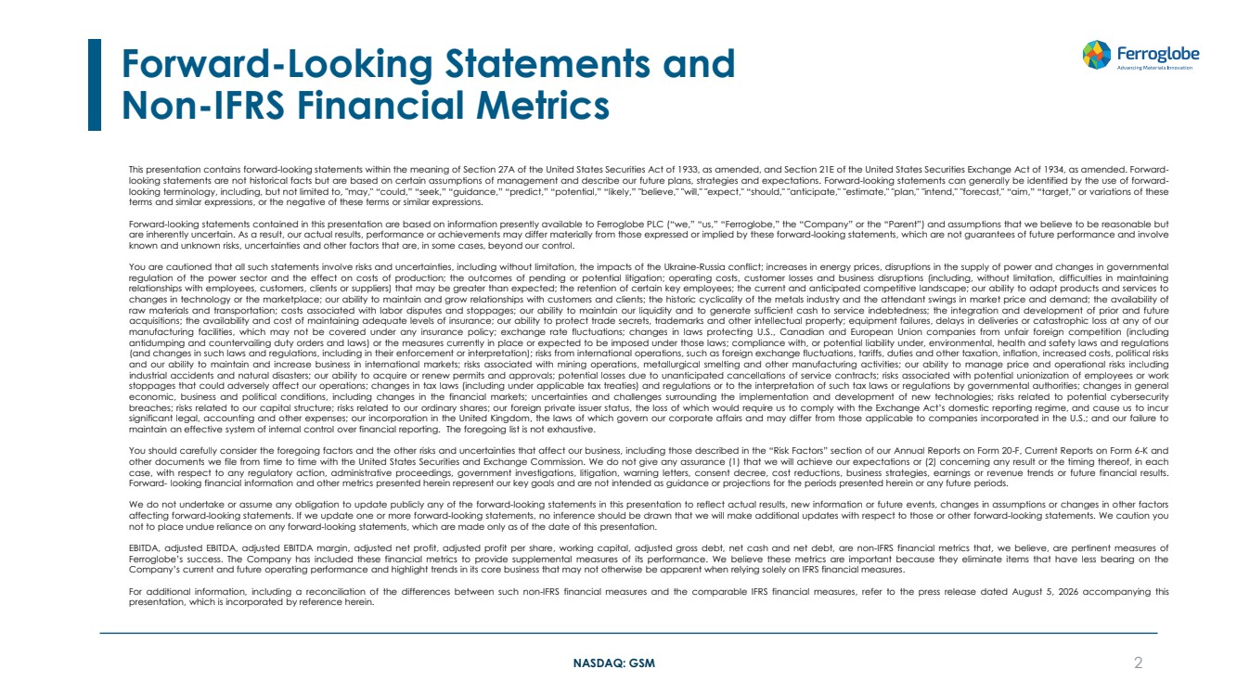 | NASDAQ: GSM Forward-Looking Statements and Non-IFRS Financial Metrics 2 This presentation contains forward-looking statements within the meaning of Section 27A of the United States Securities Act of 1933, as amended, and Section 21E of the United States Securities Exchange Act of 1934, as amended. Forward-looking statements are not historical facts but are based on certain assumptions of management and describe our future plans, strategies and expectations. Forward-looking statements can generally be identified by the use of forward-looking terminology, including, but not limited to, "may," “could,” “seek,” “guidance,” “predict,” “potential,” “likely,” "believe," "will," "expect," “should," "anticipate," "estimate," "plan," "intend," "forecast," “aim,” “target,” or variations of these terms and similar expressions, or the negative of these terms or similar expressions. Forward-looking statements contained in this presentation are based on information presently available to Ferroglobe PLC (“we,” “us,” “Ferroglobe,” the “Company” or the “Parent”) and assumptions that we believe to be reasonable but are inherently uncertain. As a result, our actual results, performance or achievements may differ materially from those expressed or implied by these forward-looking statements, which are not guarantees of future performance and involve known and unknown risks, uncertainties and other factors that are, in some cases, beyond our control. You are cautioned that all such statements involve risks and uncertainties, including without limitation, the impacts of the Ukraine-Russia conflict; increases in energy prices, disruptions in the supply of power and changes in governmental regulation of the power sector and the effect on costs of production; the outcomes of pending or potential litigation; operating costs, customer losses and business disruptions (including, without limitation, difficulties in maintaining relationships with employees, customers, clients or suppliers) that may be greater than expected; the retention of certain key employees; the current and anticipated competitive landscape; our ability to adapt products and services to changes in technology or the marketplace; our ability to maintain and grow relationships with customers and clients; the historic cyclicality of the metals industry and the attendant swings in market price and demand; the availability of raw materials and transportation; costs associated with labor disputes and stoppages; our ability to maintain our liquidity and to generate sufficient cash to service indebtedness; the integration and development of prior and future acquisitions; the availability and cost of maintaining adequate levels of insurance; our ability to protect trade secrets, trademarks and other intellectual property; equipment failures, delays in deliveries or catastrophic loss at any of our manufacturing facilities, which may not be covered under any insurance policy; exchange rate fluctuations; changes in laws protecting U.S., Canadian and European Union companies from unfair foreign competition (including antidumping and countervailing duty orders and laws) or the measures currently in place or expected to be imposed under those laws; compliance with, or potential liability under, environmental, health and safety laws and regulations (and changes in such laws and regulations, including in their enforcement or interpretation); risks from international operations, such as foreign exchange fluctuations, tariffs, duties and other taxation, inflation, increased costs, political risks and our ability to maintain and increase business in international markets; risks associated with mining operations, metallurgical smelting and other manufacturing activities; our ability to manage price and operational risks including industrial accidents and natural disasters; our ability to acquire or renew permits and approvals; potential losses due to unanticipated cancellations of service contracts; risks associated with potential unionization of employees or work stoppages that could adversely affect our operations; changes in tax laws (including under applicable tax treaties) and regulations or to the interpretation of such tax laws or regulations by governmental authorities; changes in general economic, business and political conditions, including changes in the financial markets; uncertainties and challenges surrounding the implementation and development of new technologies; risks related to potential cybersecurity breaches; risks related to our capital structure; risks related to our ordinary shares; our foreign private issuer status, the loss of which would require us to comply with the Exchange Act’s domestic reporting regime, and cause us to incur significant legal, accounting and other expenses; our incorporation in the United Kingdom, the laws of which govern our corporate affairs and may differ from those applicable to companies incorporated in the U.S.; and our failure to maintain an effective system of internal control over financial reporting. The foregoing list is not exhaustive. You should carefully consider the foregoing factors and the other risks and uncertainties that affect our business, including those described in the “Risk Factors” section of our Annual Reports on Form 20-F, Current Reports on Form 6-K and other documents we file from time to time with the United States Securities and Exchange Commission. We do not give any assurance (1) that we will achieve our expectations or (2) concerning any result or the timing thereof, in each case, with respect to any regulatory action, administrative proceedings, government investigations, litigation, warning letters, consent decree, cost reductions, business strategies, earnings or revenue trends or future financial results. Forward- looking financial information and other metrics presented herein represent our key goals and are not intended as guidance or projections for the periods presented herein or any future periods. We do not undertake or assume any obligation to update publicly any of the forward-looking statements in this presentation to reflect actual results, new information or future events, changes in assumptions or changes in other factors affecting forward-looking statements. If we update one or more forward-looking statements, no inference should be drawn that we will make additional updates with respect to those or other forward-looking statements. We caution you not to place undue reliance on any forward-looking statements, which are made only as of the date of this presentation. EBITDA, adjusted EBITDA, adjusted EBITDA margin, adjusted net profit, adjusted profit per share, working capital, adjusted gross debt, net cash and net debt, are non-IFRS financial metrics that, we believe, are pertinent measures of Ferroglobe’s success. The Company has included these financial metrics to provide supplemental measures of its performance. We believe these metrics are important because they eliminate items that have less bearing on the Company’s current and future operating performance and highlight trends in its core business that may not otherwise be apparent when relying solely on IFRS financial measures. For additional information, including a reconciliation of the differences between such non-IFRS financial measures and the comparable IFRS financial measures, refer to the press release dated August 5, 2026 accompanying this presentation, which is incorporated by reference herein.
 | 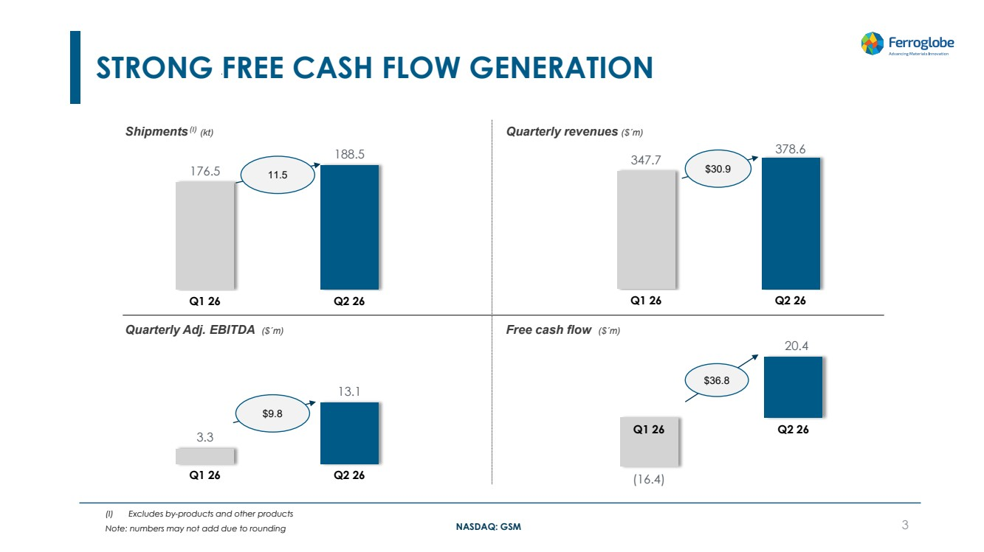 | NASDAQ: GSM 347.7 378.6 Q1 26 Q2 26 (16.4) 20.4 Q1 26 Q2 26 3.3 13.1 Q1 26 Q2 26 STRONG FREE CASH FLOW GENERATION 3 Shipments (I) (kt) Quarterly revenues ($´m) Quarterly Adj. EBITDA ($´m) Free cash flow ($´m) 176.5 188.5 Q1 26 Q2 26 $36.8 11.5 (I) Excludes by-products and other products Note: numbers may not add due to rounding $30.9 $9.8
 | 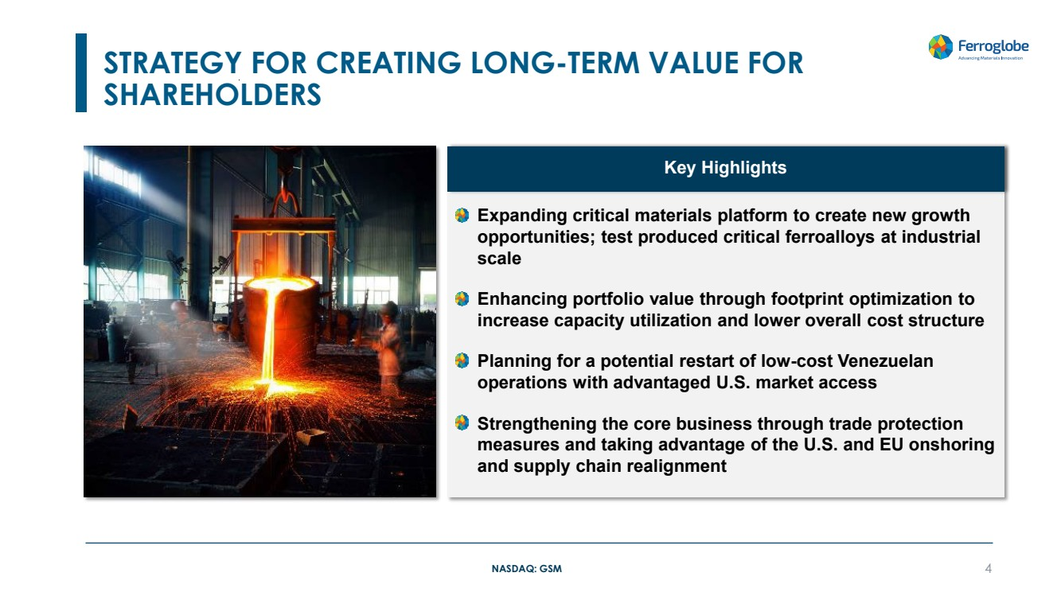 | NASDAQ: GSM STRATEGY FOR CREATING LONG-TERM VALUE FOR SHAREHOLDERS 4 • Expanding critical materials platform to create new growth opportunities; test produced critical ferroalloys at industrial scale • Enhancing portfolio value through footprint optimization to increase capacity utilization and lower overall cost structure • Planning for a potential restart of low-cost Venezuelan operations with advantaged U.S. market access • Strengthening the core business through trade protection measures and taking advantage of the U.S. and EU onshoring and supply chain realignment Key Highlights
 | 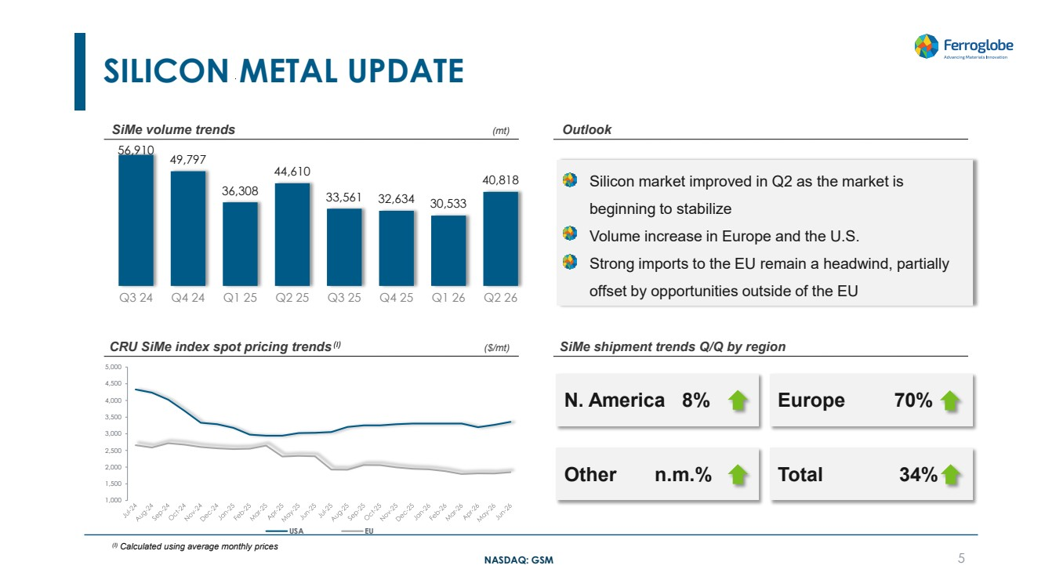 | NASDAQ: GSM SILICON METAL UPDATE 56,910 49,797 36,308 44,610 33,561 32,634 30,533 40,818 Q3 24 Q4 24 Q1 25 Q2 25 Q3 25 Q4 25 Q1 26 Q2 26 CRU SiMe index spot pricing trends (I) ($/mt) SiMe shipment trends Q/Q by region SiMe volume trends (mt) Outlook Other n.m.% Total 34% N. America 8% Europe 70% 5 • Silicon market improved in Q2 as the market is beginning to stabilize • Volume increase in Europe and the U.S. • Strong imports to the EU remain a headwind, partially offset by opportunities outside of the EU (I) Calculated using average monthly prices 1,000 1,500 2,000 2,500 3,000 3,500 4,000 4,500 5,000 USA EU
 | 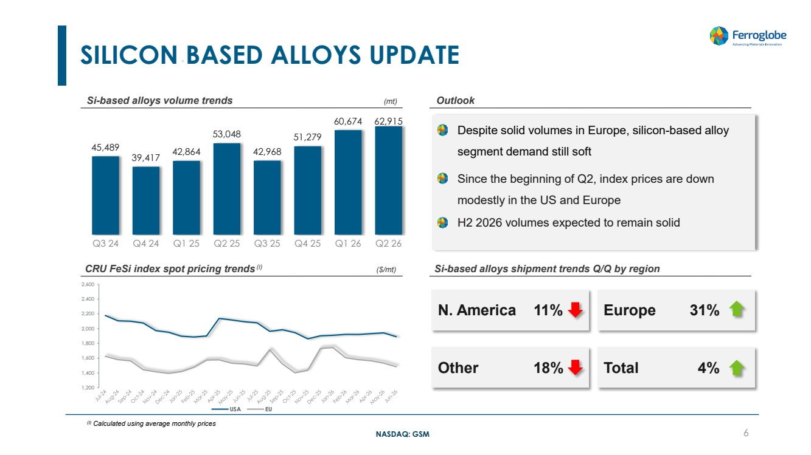 | NASDAQ: GSM SILICON BASED ALLOYS UPDATE 45,489 39,417 42,864 53,048 42,968 51,279 60,674 62,915 Q3 24 Q4 24 Q1 25 Q2 25 Q3 25 Q4 25 Q1 26 Q2 26 CRU FeSi index spot pricing trends (I) ($/mt) Si-based alloys shipment trends Q/Q by region Si-based alloys volume trends (mt) Outlook Other 18% Total 4% N. America 11% Europe 31% 6 • Despite solid volumes in Europe, silicon-based alloy segment demand still soft • Since the beginning of Q2, index prices are down modestly in the US and Europe • H2 2026 volumes expected to remain solid (I) Calculated using average monthly prices 1,200 1,400 1,600 1,800 2,000 2,200 2,400 2,600 USA EU
 | 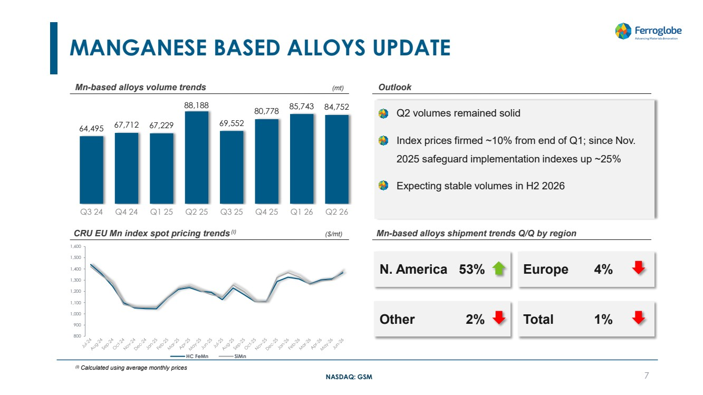 | NASDAQ: GSM • Q2 volumes remained solid • Index prices firmed ~10% from end of Q1; since Nov. 2025 safeguard implementation indexes up ~25% • Expecting stable volumes in H2 2026 MANGANESE BASED ALLOYS UPDATE 64,495 67,712 67,229 88,188 69,552 80,778 85,743 84,752 Q3 24 Q4 24 Q1 25 Q2 25 Q3 25 Q4 25 Q1 26 Q2 26 CRU EU Mn index spot pricing trends (I) ($/mt) Mn-based alloys shipment trends Q/Q by region Mn-based alloys volume trends (mt) Outlook Other 2% Total 1% N. America 53% Europe 4% 7 (I) Calculated using average monthly prices 800 900 1,000 1,100 1,200 1,300 1,400 1,500 1,600 HC FeMn SiMn
 |  | NASDAQ: GSM FINANCE UPDATE
 | 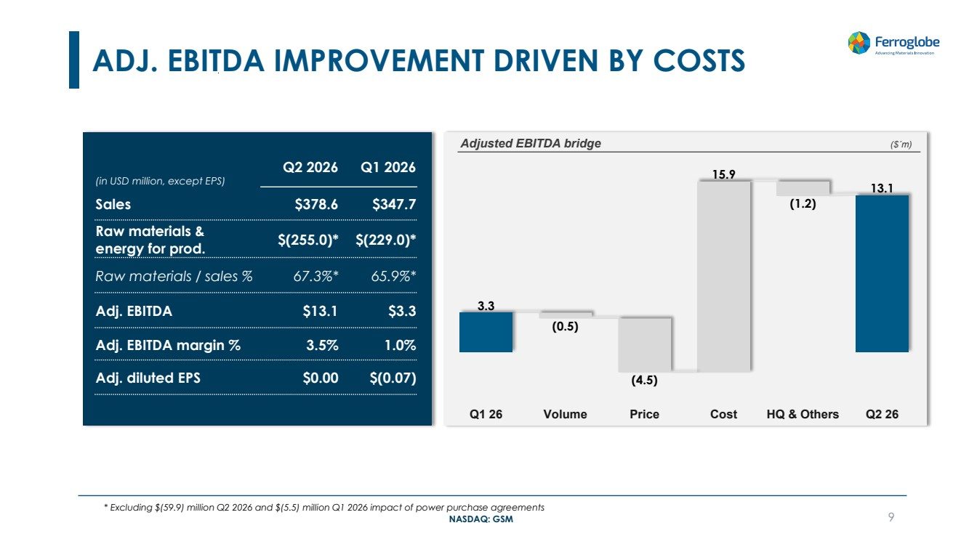 | NASDAQ: GSM ADJ. EBITDA IMPROVEMENT DRIVEN BY COSTS 9 (in USD million, except EPS) Q2 2026 Q1 2026 Sales $378.6 $347.7 Raw materials & energy for prod. $(255.0)* $(229.0)* Raw materials / sales % 67.3%* 65.9%* Adj. EBITDA $13.1 $3.3 Adj. EBITDA margin % 3.5% 1.0% Adj. diluted EPS $0.00 $(0.07) Adjusted EBITDA bridge ($´m) * Excluding $(59.9) million Q2 2026 and $(5.5) million Q1 2026 impact of power purchase agreements 3.3 (0.5) (4.5) 15.9 (1.2) 13.1 Q1 26 Volume Price Cost HQ & Others Q2 26
 | 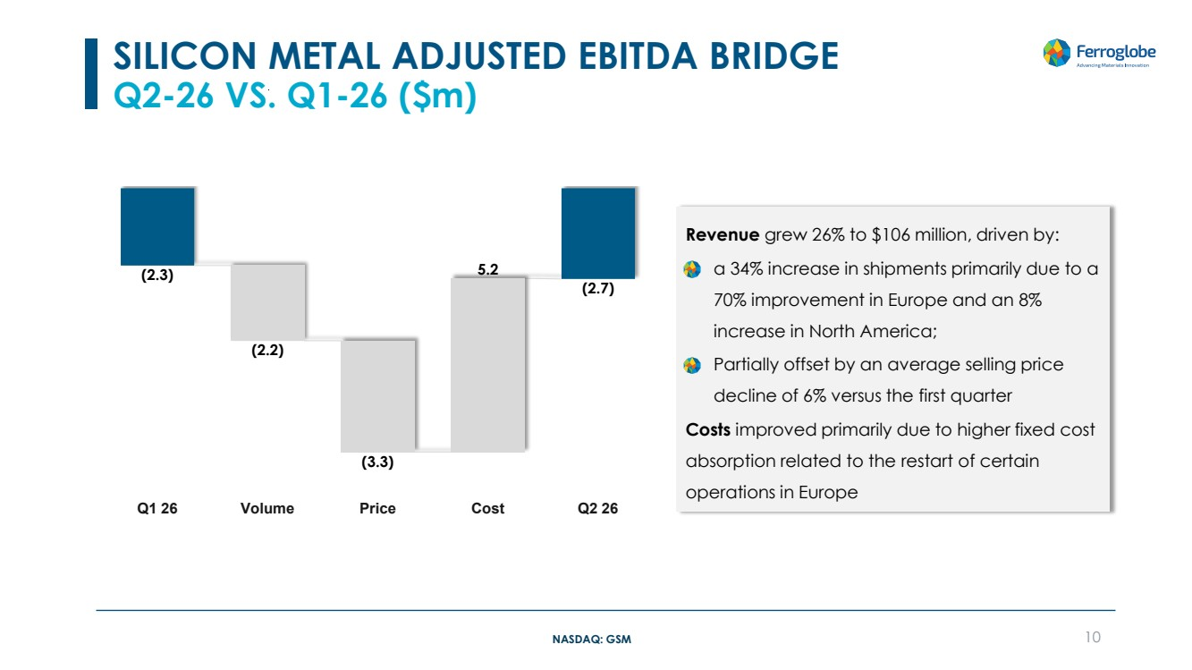 | NASDAQ: GSM Revenue grew 26% to $106 million, driven by: • a 34% increase in shipments primarily due to a 70% improvement in Europe and an 8% increase in North America; • Partially offset by an average selling price decline of 6% versus the first quarter Costs improved primarily due to higher fixed cost absorption related to the restart of certain operations in Europe SILICON METAL ADJUSTED EBITDA BRIDGE Q2-26 VS. Q1-26 ($m) 10 (2.3) (2.2) (3.3) 5.2 (2.7) Q1 26 Volume Price Cost Q2 26
 | 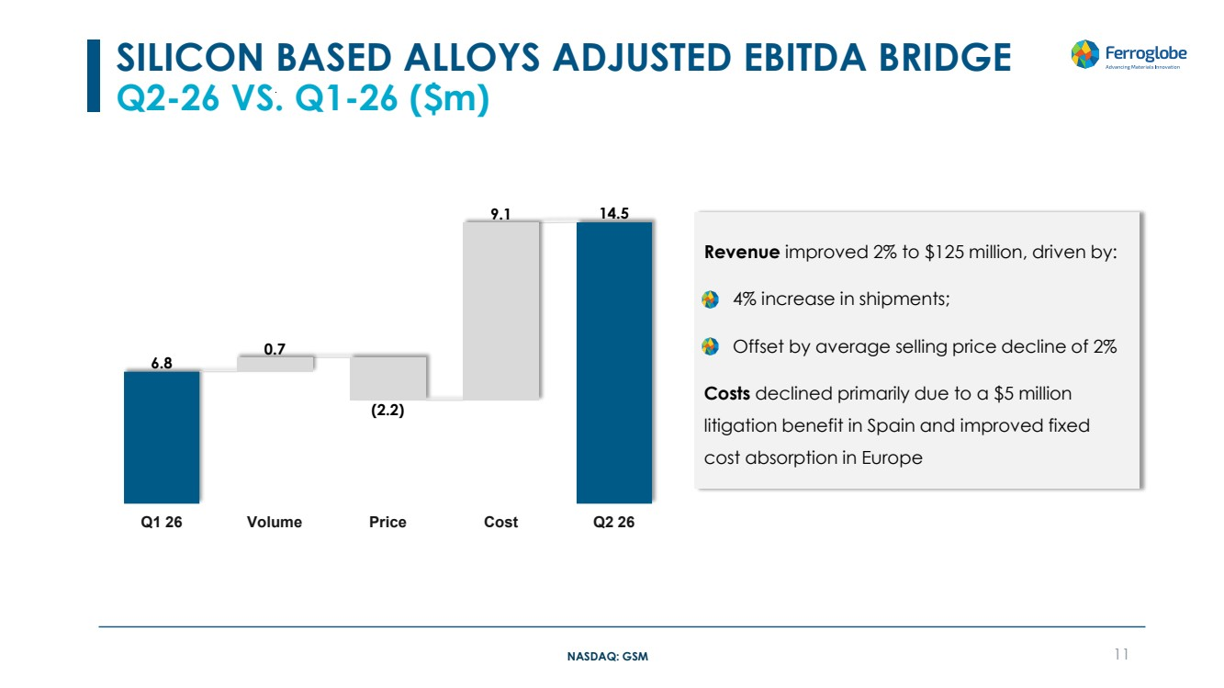 | NASDAQ: GSM Revenue improved 2% to $125 million, driven by: • 4% increase in shipments; • Offset by average selling price decline of 2% Costs declined primarily due to a $5 million litigation benefit in Spain and improved fixed cost absorption in Europe SILICON BASED ALLOYS ADJUSTED EBITDA BRIDGE Q2-26 VS. Q1-26 ($m) 11 6.8 0.7 (2.2) 9.1 14.5 Q1 26 Volume Price Cost Q2 26
 | 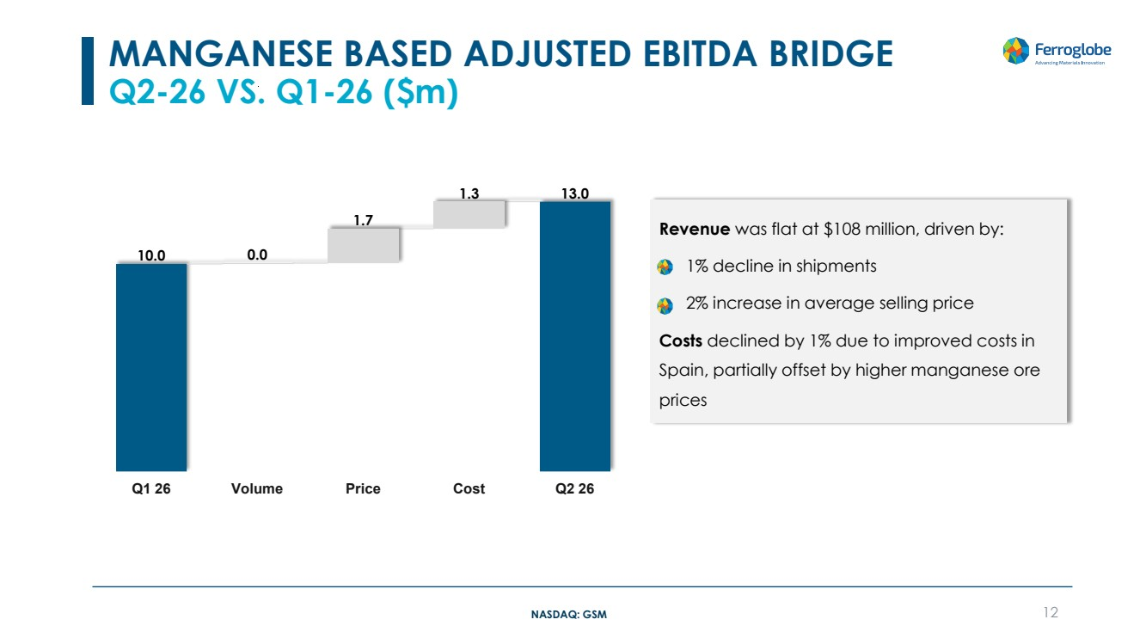 | NASDAQ: GSM Revenue was flat at $108 million, driven by: • 1% decline in shipments • 2% increase in average selling price Costs declined by 1% due to improved costs in Spain, partially offset by higher manganese ore prices MANGANESE BASED ADJUSTED EBITDA BRIDGE Q2-26 VS. Q1-26 ($m) 12 10.0 0.0 1.7 1.3 13.0 Q1 26 Volume Price Cost Q2 26
 | 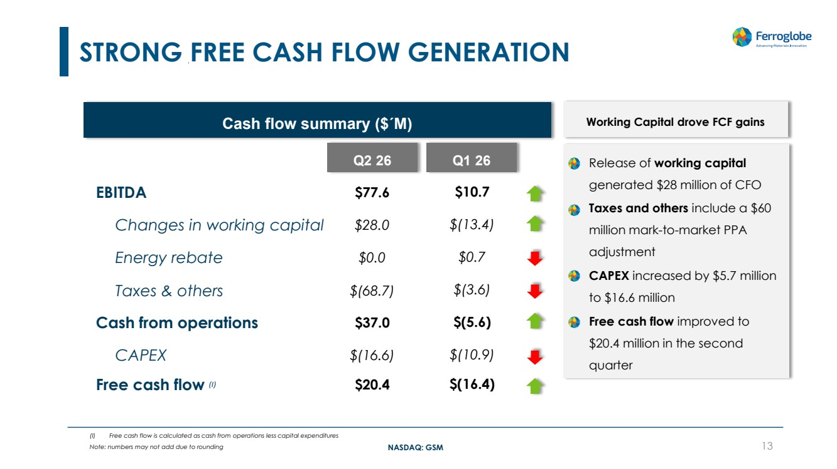 | NASDAQ: GSM STRONG FREE CASH FLOW GENERATION 13 Cash flow summary ($´M) Changes in working capital Free cash flow (I) CAPEX Taxes & others Cash from operations Q2 26 $77.6 $28.0 $(68.7) $37.0 $20.4 $(16.6) EBITDA Energy rebate $0.0 • Release of working capital generated $28 million of CFO • Taxes and others include a $60 million mark-to-market PPA adjustment • CAPEX increased by $5.7 million to $16.6 million • Free cash flow improved to $20.4 million in the second quarter Q1 26 Working Capital drove FCF gains (I) Free cash flow is calculated as cash from operations less capital expenditures Note: numbers may not add due to rounding $10.7 $(13.4) $(3.6) $(5.6) $(16.4) $(10.9) $0.7
 | 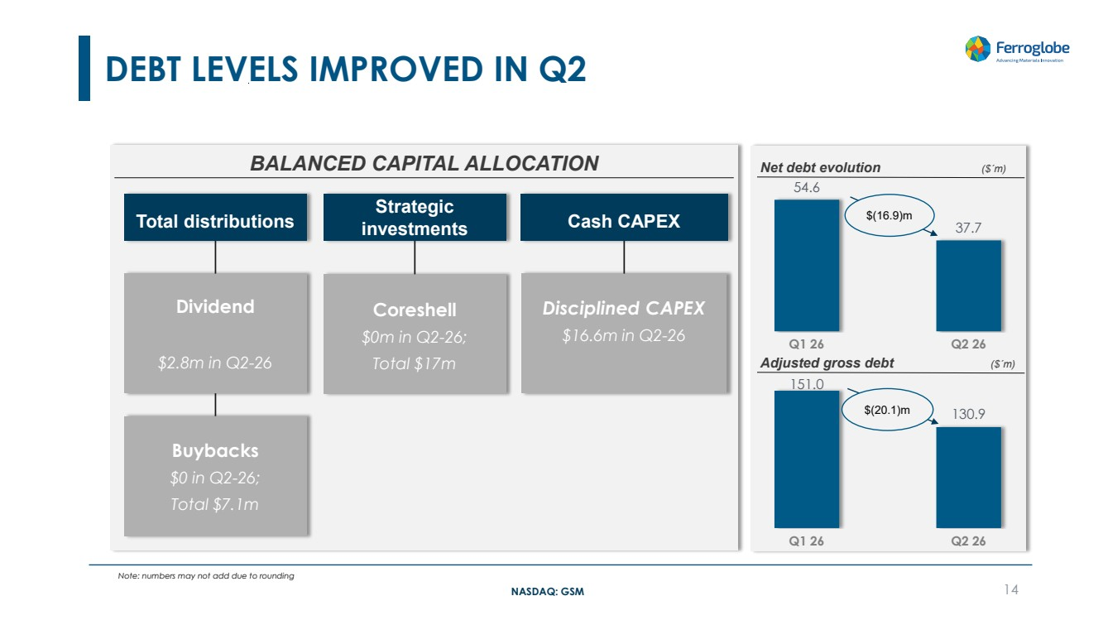 | NASDAQ: GSM DEBT LEVELS IMPROVED IN Q2 14 Total distributions BALANCED CAPITAL ALLOCATION Cash CAPEX Buybacks $0 in Q2-26; Total $7.1m Dividend $2.8m in Q2-26 Coreshell $0m in Q2-26; Total $17m Disciplined CAPEX $16.6m in Q2-26 54.6 37.7 Q1 26 Q2 26 Net debt evolution ($´m) Adjusted gross debt ($´m) 151.0 130.9 Q1 26 Q2 26 $(20.1)m Strategic investments Note: numbers may not add due to rounding $(16.9)m
 | 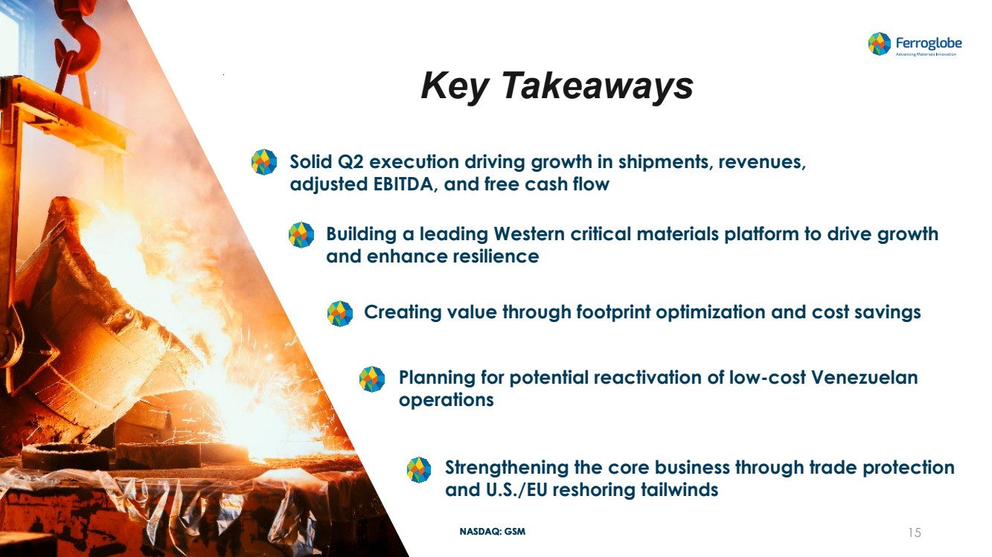 | NASDAQ: GSM Key Takeaways Creating value through footprint optimization and cost savings Strengthening the core business through trade protection and U.S./EU reshoring tailwinds 15 Solid Q2 execution driving growth in shipments, revenues, adjusted EBITDA, and free cash flow Building a leading Western critical materials platform to drive growth and enhance resilience Planning for potential reactivation of low-cost Venezuelan operations
 |  | NASDAQ: GSM Q&A
 |  | NASDAQ: GSM Appendix ─ Supplemental Information
 | 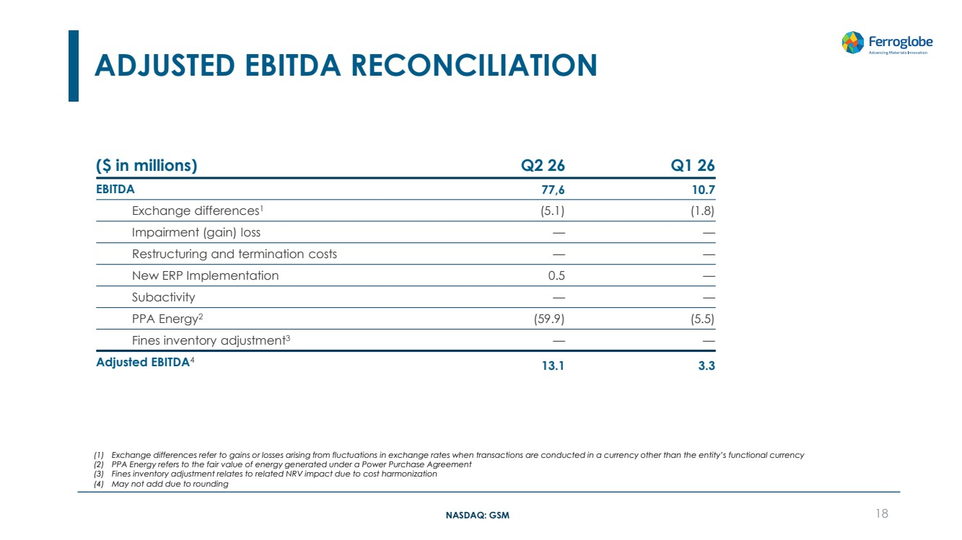 | NASDAQ: GSM ADJUSTED EBITDA RECONCILIATION 18 ($ in millions) Q2 26 Q1 26 EBITDA 77,6 10.7 Exchange differences1 (5.1) (1.8) Impairment (gain) loss — — Restructuring and termination costs — — New ERP Implementation 0.5 — Subactivity — — PPA Energy2 (59.9) (5.5) Fines inventory adjustment3 — — Adjusted EBITDA4 13.1 3.3 (1) Exchange differences refer to gains or losses arising from fluctuations in exchange rates when transactions are conducted in a currency other than the entity’s functional currency (2) PPA Energy refers to the fair value of energy generated under a Power Purchase Agreement (3) Fines inventory adjustment relates to related NRV impact due to cost harmonization (4) May not add due to rounding
 | 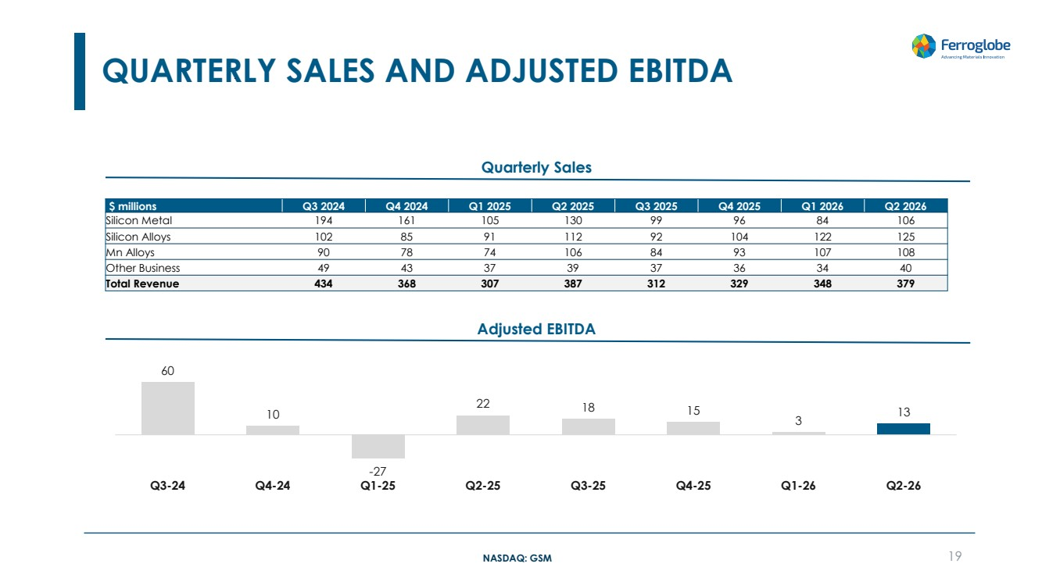 | NASDAQ: GSM QUARTERLY SALES AND ADJUSTED EBITDA 19 Adjusted EBITDA Quarterly Sales $ millions Q3 2024 Q4 2024 Q1 2025 Q2 2025 Q3 2025 Q4 2025 Q1 2026 Q2 2026 Silicon Metal 194 161 105 130 99 96 84 106 Silicon Alloys 102 85 91 112 92 104 122 125 Mn Alloys 90 78 74 106 84 93 107 108 Other Business 49 43 37 39 37 36 34 40 Total Revenue 434 368 307 387 312 329 348 379 60 10 -27 22 18 15 3 13 Q3-24 Q4-24 Q1-25 Q2-25 Q3-25 Q4-25 Q1-26 Q2-26
 |  | NASDAQ: GSM Investor Relations Alex Rotonen Vice President, Investor Relations investor.relations@ferroglobe.com Media Inquiries Cristina Feliu Roig Vice President, Communications & Public Affairs NASDAQ: GSM corporate.comms@ferroglobe.com

